ISTE-230 Introduction to Database and Data Modeling

Practice Exercise # 8 – ‘IS-A’ Relationships

Name: Korben Reehill

All assignments will be graded with regard to the standards that were discussed in class, which can be found in the Standards Content area.

Problem #1
Given the following business rules, please extend the E-R diagram provided below.
- Each CONTACT doesn’t have to be, but could be classified as any combination of the following: CO-WORKER, VENDOR, and PERSONAL.

- If the CONTACT is a CO-WORKER, then the office_number will be stored.

- A VENDOR will have one or more VENDOR_TYPEs.

- A VENDOR TYPE is uniquely identified by vendor_typeID. In addition, a description is provided.

- A VENDOR_TYPE doesn’t have to apply to any instances of VENDOR, but could apply to many different VENDORs.

- If the CONTACT is a PERSONAL, then the street, city, state, zip should be tracked for the home address.

- Every PERSONAL CONTACT, must be either a RELATIVE or a FRIEND, but never both.

- For a RELATIVE the relationship will be stored, such as mother, father, cousin, etc.

- For a FRIEND, where that friend was met will be stored, such as elementary school, middle school, high school, college, camp, etc.
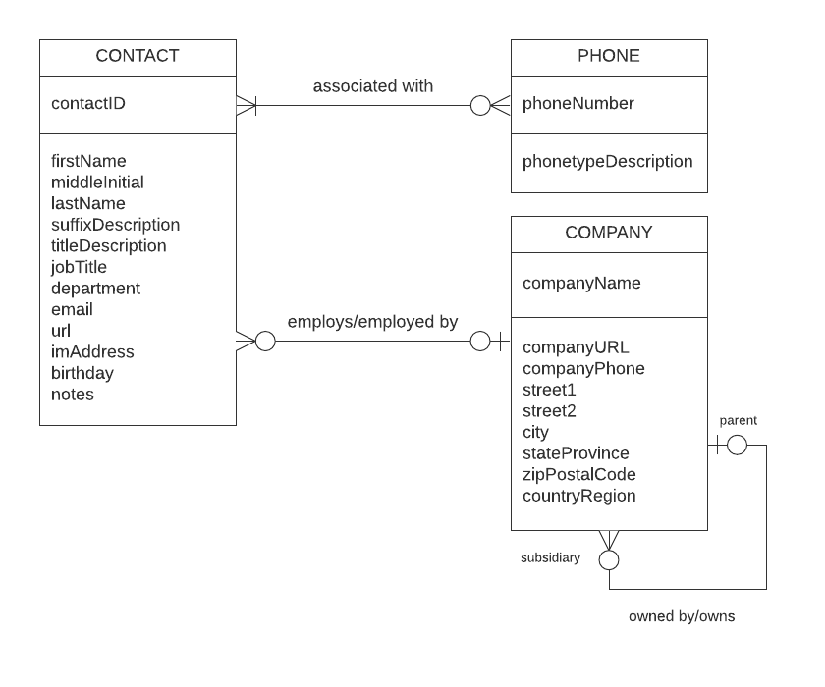
YOUR ANSWER (Diagram above completed):
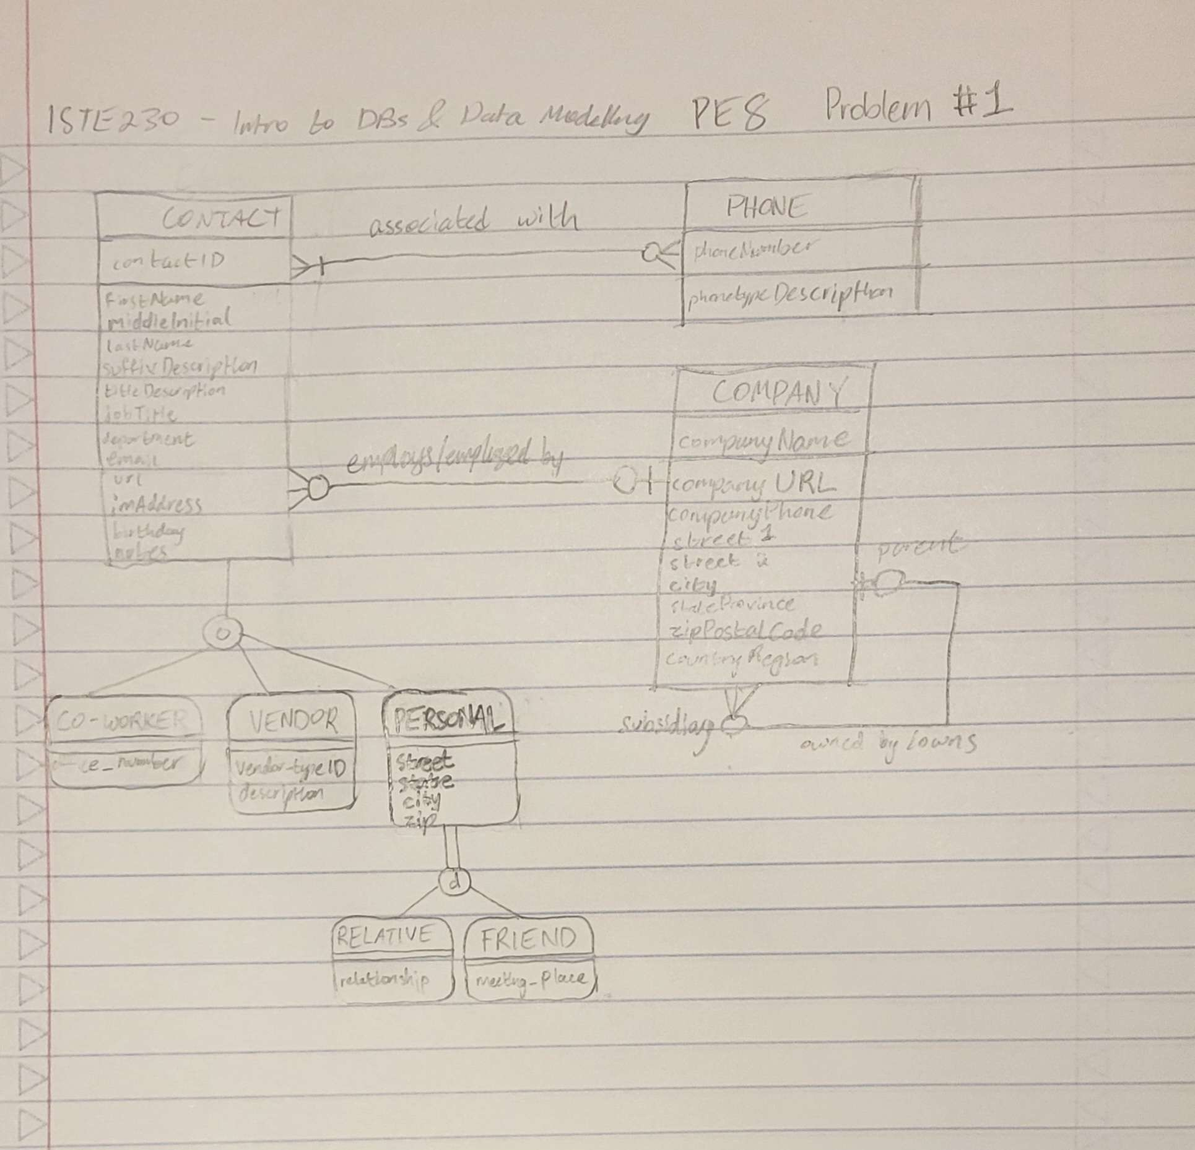

Problem #2
Using your knowledge of the scenario described above, please answer the following questions.

A. If a discriminator were to be added to CONTACT, what attribute(s) would you add?

YOUR ANSWER:
contact_type

B. If a discriminator were to be added to PERSONAL, what attribute(s) would you add?

YOUR ANSWER:
relationship_type

